WEEK-07

1.Given an array of strings words, return *the words that can be typed using letters of the alphabet on only one row of American keyboard like the image below*.

In the **American keyboard**:

* the first row consists of the characters "qwertyuiop",
* the second row consists of the characters "asdfghjkl", and
* the third row consists of the characters "zxcvbnm".

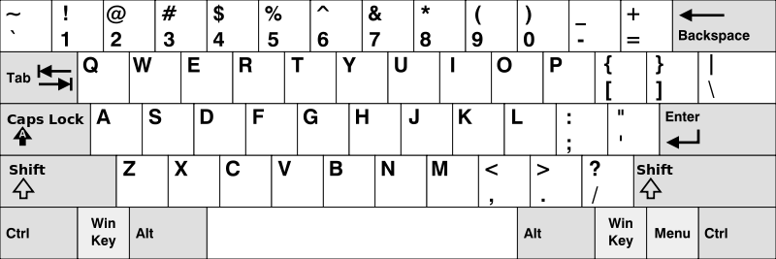

**Example 1:**

**Input:** words = ["Hello","Alaska","Dad","Peace"]

**Output:** ["Alaska","Dad"]

**Example 2:**

**Input:** words = ["omk"]

**Output:** []

**Example 3:**

**Input:** words = ["adsdf","sfd"]

**Output:** ["adsdf","sfd"]

**For example:**

| **Input** | **Result** |
| --- | --- |
| 4  Hello  Alaska  Dad  Peace | Alaska  Dad |
| 2  adsfd  afd | adsfd  afd |

**PROGRAM:**

**def check(name,row):**

**for i in name:**

**if(not(i in row)):**

**return False**

**return True**

**name=[input() for i in range(int(input()))]**

**r1='qwertyuiopQWERTYUIOP'**

**r2='asdfghjklASDFGHJKL'**

**r3='zxcvbnmZXCVBNM'**

**result=[]**

**for i in name:**

**if(i[0] in r1):**

**x=r1**

**elif(i[0] in r2):**

**x=r2**

**else:**

**x=r3**

**if(check(i,x)):**

**result.append(i)**

**if result:**

**for i in result:**

**print(i)**

**else:**

**print('No words')**

**OUTPUT:**

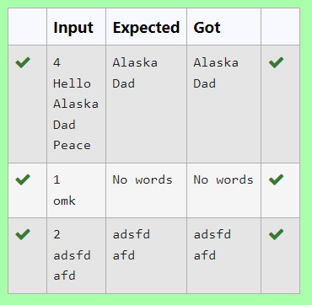

**2.** Given an array of integers nums containing n + 1 integers where each integer is in the range [1, n] inclusive.There is only **one repeated number** in nums, return *this repeated number*. Solve the problem using set.

**Example 1:**

**Input:** nums = [1,3,4,2,2]

**Output:** 2

**Example 2:**

**Input:** nums = [3,1,3,4,2]

**Output:** 3

**For example:**

| **Input** | **Result** |
| --- | --- |
| 1 3 4 4 2 | 4 |

**PROGRAM:**

**def find_duplicate(nums):**

**num_set = set()**

**for num in nums:**

**if num in num_set:**

**return num**

**else:**

**num_set.add(num)**

**nums=list(map(int,input().split()))**

**print(find_duplicate(nums))**

**OUTPUT:**

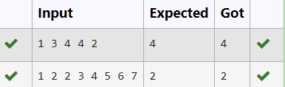

**3.** The **DNA sequence** is composed of a series of nucleotides abbreviated as 'A', 'C', 'G', and 'T'.

* For example, "ACGAATTCCG" is a **DNA sequence**.

When studying **DNA**, it is useful to identify repeated sequences within the DNA.

Given a string s that represents a **DNA sequence**, return all the **10-letter-long** sequences (substrings) that occur more than once in a DNA molecule. You may return the answer in **any order**.

**Example 1:**

**Input:** s = "AAAAACCCCCAAAAACCCCCCAAAAAGGGTTT"

**Output:** ["AAAAACCCCC","CCCCCAAAAA"]

**Example 2:**

**Input:** s = "AAAAAAAAAAAAA"

**Output:** ["AAAAAAAAAA"]

**For example:**

| **Input** | **Result** |
| --- | --- |
| AAAAACCCCCAAAAACCCCCCAAAAAGGGTTT | AAAAACCCCC  CCCCCAAAAA |

**PROGRAM:**

**def findRepeatedDnaSequences(s):**

**sequences = {}**

**result = []**

**for i in range(len(s) - 9):**

**sequence = s[i:i+10]**

**if sequence in sequences:**

**if sequences[sequence] == 1:**

**result.append(sequence)**

**sequences[sequence] += 1**

**else:**

**sequences[sequence] = 1**

**return "\n".join(result)**

**s = input()**

**print(findRepeatedDnaSequences(s))**

**OUTPUT:**

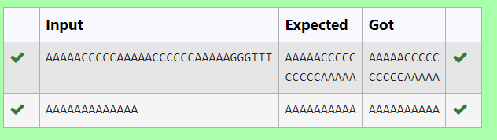

**4.** Coders here is a simple task for you, Given string str. Your task is to check whether it is a binary string or not by using python set.

Examples:

Input: str = "01010101010"

Output: Yes

Input: str = "REC101"

Output: No

**For example:**

| **Input** | **Result** |
| --- | --- |
| 01010101010 | Yes |
| 010101 10101 | No |

**PROGRAM:**

**def is_binary_string(s):**

**binary_set = {'0', '1'}**

**return set(s) <= binary_set**

**# Input processing**

**def main():**

**s = input()**

**if is_binary_string(s):**

**print("Yes")**

**else:**

**print("No")**

**if __name__ == "__main__":**

**main()**

**OUTPUT:**

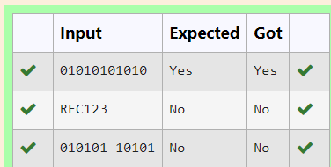

**5.** Given a tuple and a positive integer k, the task is to find the count of distinct pairs in the tuple whose sum is equal to **K**.

**Examples:**

**Input:** t = (5, 6, 5, 7, 7, 8 ), K = 13   
**Output:** 2   
**Explanation:**   
Pairs with sum K( = 13) are  {(5, 8), (6, 7), (6, 7)}.   
Therefore, distinct pairs with sum K( = 13) are { (5, 8), (6, 7) }.   
Therefore, the required output is 2.

**For example:**

| **Input** | **Result** |
| --- | --- |
| 1,2,1,2,5  3 | 1 |
| 1,2  0 | 0 |

**PROGRAM:**

**t=tuple(input().split(','))**

**t=tuple(int(i)for i in t)**

**k=int(input())**

**result=[]**

**for i in t:**

**for j in t:**

**if(i+j==k and not ([i,j] in result or [j,i]in result)):**

**result.append([i,j])**

**print(len(result))**

**OUTPUT:**

